Supplementary material for the manuscript entitled “Post-hospital medical respite care for homeless people in Denmark: A randomized controlled trial and cost-utility analysis.”

Figure S1: Cost-effectiveness plane, imputed QALY’s
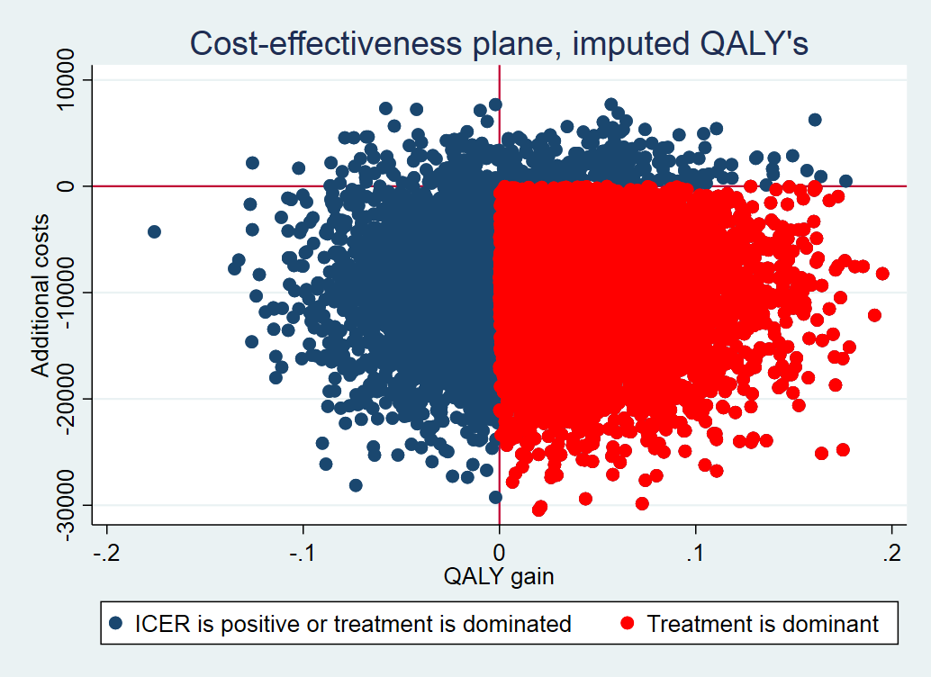

Table S1: Services received at Medical respite care
Service | n (%)N=53
No help | 11 (21)
Health care related help
contact to general practitioner | 3 (6)
contact to hospital | 15 (28)
Provide medication | 13 (25)
Guidance of medicine | 27 (51)
Wound care | 15 (28)
Contact to or visit at dentist | 1 (2)
Contact to or stay at abuse centre | 8 (15)
Contact to social health care initiatives | 16 (30)
Social related help
Contact to social initiatives | 20 (38)
Temporary housing | 12 (23)
Help to personal finances or economic support | 4 (8)
Subsequent contact or follow-up | 16 (30)
complete cleaning of house | 4 (8)
contact to relatives or social network | 2 (4)
Guidance in self-care or provided clothing | 23 (43)

